Case Study

Impressed by your programs implemented in Assessment 2, the stakeholders of the restaurant have asked you to develop a program extending Assessment 2. In this assessment, you will have to use the Object Orientated Programming (OOP) paradigm. Please, read the following case study with a fresh mind, as it is NOT the same as the one in Assessment 2.

This program should enable the logged in user to place orders through the App. In response to the covid safety measures, the restaurant is offering the customers the following possibilities of contact-less placing of orders:
- Dine in: While at restaurant users place contactless orders. Users have to pay additional service charges to their orders.
- Pick up: users place remote orders to be picked up either to save the delivery costs or because the restaurant does not deliver to their address. Delivery: users place remote orders and have them delivered to their address. Users have to pay extra delivery charges.

The program should follow the below general structure:
When a user runs the program, the below choices should be provided: 1- Sign up
- Login: upon successful login the users can then do the following.

Ordering (Dine in, Takeaway, Delivery),
  - Print Statistics
  - Logout
- Exit

Output:
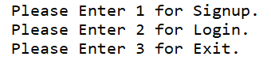

Task 1. Signup/Login Process for Customers
A user should sign up to use the services provided by the app. Before placing an order, the user should successfully login to the application. Please create a signup and a login function while making use of your assessment 2 code.

Signup

Step 1: Each Customer is advised to submit the required details for signup process.

The mobile number has 10 digits starting with 0.
  - The Password must initiate with alphabets followed by either one of @,#, $ and ending with numeric. (For Example: Sam@0125)
  - The password confirmation matches the initial entered password.
  - The DOB is in the format DD/MM/YYYY
  - The user is at least 18 years old. The age should be calculated based on the year entered in the DOB (Only consider year).

Note: If any of the above-mentioned condition is not fulfilled; the sign-up process should fail, and a descriptive message should be displayed for the user explaining what has gone wrong and providing hints on the correct expected input. The program should keep asking the user to re-enter his details as long as one or more of the input fields are not correctly filled. If all fields are completed successfully, the program should stop asking the user to re-enter his details and display a message that the signup process is completed successfully.
If all of the above-mentioned conditions are successful, the user data is saved in Lists to enable data checks during the login process.

Step 2: There is an additional field for entering the address, (Optional) Step 3: Submit
Step 4: A message of Signup Successful must be displayed.

Output:
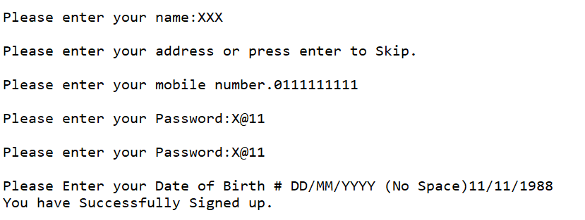

- Log in

Step 1: Each customer is advised to enter the login id and password for the sign in,

Step 2: Post Successful Login the User must be presented with a variety of options to Proceed (Home Page):

2.1 Ordering (Dine in, Click and collect, Delivery), 2.2Summary of Transactions
2.3Logout

Output:
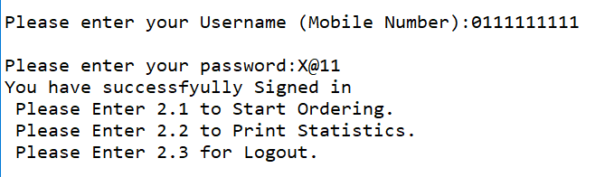

Task 2: Ordering

Post Selecting the Option of 2.1 the User must be taken to the Ordering Page. In the ordering page, the following options should be offered:
- Dine in
- Order Online
- Go To Login Page

Output:
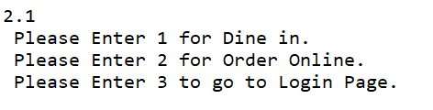

In case of Selecting the Option 2, the User must be taken to the next page, where the following options should be offered:

  - Self-Pickup
  - Home Delivery
  - Go To Previous Menu

Output:
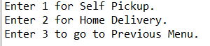

After the user successfully selects the ordering mode, the user should be presented with the menu in the form of:

ID | Name |  | Price
1 | XXXX | XX
2 | XXXX | XX
3 | XXXX | XX
4 | XXXX | XX
5 | XXXX | XX
6 | XXXX | XX
7 | Checkout

Output:
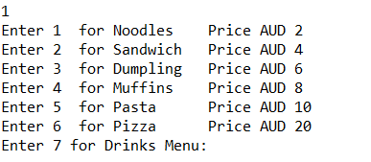
Please note:
- The menu will only have 6 items for the Click and collect and delivery modes.
- If dine in mode is selected the user menu should have 6 items followed by 3 drinks items presented after the Food Menu.
- The user should be able to order as many items as they wish. To close the Food menu and proceed to the Drink Menu the user needs to selects option 7.

Output:
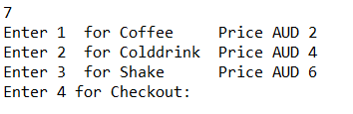

- To close the Drink Menu and proceed to the Checkout the user needs to select option 4.
- Post Checkout the user must be advised with the total amount needed to be paid.
- The user will then be provided with three options:
  - Proceed with payment
  - Cancel order

Output:


Note: User must not be allowed to proceed for the Delivery option if the user has not mentioned their address during the signup process and must be asked to add the same before proceeding for the delivery or taken back to the Ordering Menu to select other option.

Output:
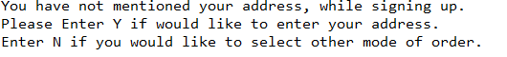

- Calculation for the Amount Need to be paid: 1- Dine in mode:
Dine in has an additional 10% service Charges to be added additionally in the Invoice.

Output:

- Click and Collect mode:
No additional Charges for click and collect

Delivery mode:
A fix charges for Delivery based on the distance i.e. More than 0 to 2 Kms AUD 5
More than 2 to 5 Kms AUD 10
More than 5 to 10 Kms AUD 18
More than 10Kms No Delivery provided

Output:

- Proceeding with the Order

If the user decides to proceed with the order, the user is requested to insert further details based on their selected ordering mode as follows:

For Dine in:
  - Number of Persons:
  - Date of Visit: DD/MM/YYYY
  - Time of Visit: HH:MM

Output:
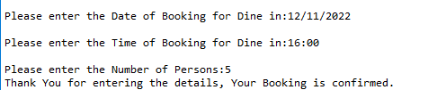

For Pick up:
  - Date of Pickup: DD/MM/YYYY
  - Time of Pickup: HH:MM
  - Name of Person Picking up:

Output:
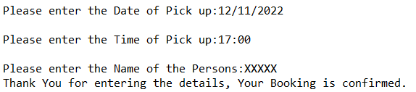

Delivery:
  - Date of Delivery:
  - Time of Delivery:
  - Distance from the Restaurant (In Kms):

Output:
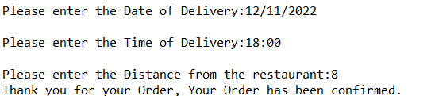

Notes:
- If the distance from the restaurant is more than the applicable limits, then the user must be provided with the option to Pick up the Order.

- Once the details have been successfully entered, user must be provided with a confirmation message with the order number.

- “Your order has been confirmed, and your order id is ‘A001’ ”

- Then the user must be taken to the Main menu.

Task 3: Summary of Transactions

A user must be shown an option to see the history of its previous orders in:

Output:
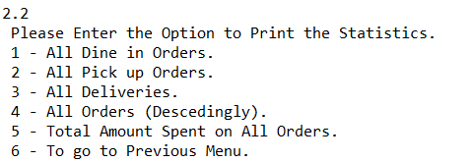
Option 1: All Dine in orders Output:
Order ID Date Type of Order Order Amount

Option 2: All Pickup Orders Output:
Order ID Date Type of Order Order Amount

Option 3: All Deliveries Output:
Order ID Date Type of Order Order Amount

Option 4: All Orders in Descending order (based on Order ID) Output:
Order ID Date Type of Order Order Amount

Option 5: Total Amount Spent (All Type of Orders i.e. Dine in, Deliveries and Pickups)

Output:

Option 6: Go to Previous Menu

